**Web Application Project**

CREATING A WEB APPLICATION OF SALES FOR JOVERTECH

In Partial Fulfillment of the Requirements for the Course

BSIT-2C

Submitted by

JOHN VINCENT M. MENDOZA

KURT JOHNZEL L. BLASURCA

Submitted to

Rics Rojas, MIT

Asst. Professor

Submitted on

1. MARCH-2023
2. **Introduction**

The JoverTech service repair shop was established on the 14th of October in 888 Chinatown Square Bacolod. The name JoverTech was named after the owner’s last name Rodolfo Jover. Since before the business was not even established, He himself already have a lot of customers/clients that are approaching to repair different devices.The JoverTech provides free checkup of devices. It offers different kinds of repair like LCD replacements, charging port, water damage, unlock passwords and many more.

Due to its great increase in customers, the shop needs to have another level when it comes to recording every client that has a history of transactions in the shop. Without the online recording, business could possibly become a slow process due to its manual work. It is essential to the business to keep tracking the transactions in order to know the sales that it earned.

One solution to this challenge is the implementation of an online recording of sales. By utilizing an online recording of sales. In addition, an online recording of sales can provide businesses with real-time updates on the record of every transaction and let them know what services have been offered to the customers, which can save valuable time and resources that would otherwise be required to carry out these tasks manually.

1. **Planning**

The Group 1 decided to make a website application of sales for the JoverTech to have an easy and less hassle to input data and sales.It is also one of the essential needs of the business. It contains the history of purchases, Services offered, Technicians and prices. The owner of the JoverTech will make use of this web application to record every transactions that have been contacted.

During an entire week of making, Group 1 decided to split the tasks and assign who would be in charge of the front end and back end. The GANTT chart below shows what specific day the code was made and who is in charge of the work.

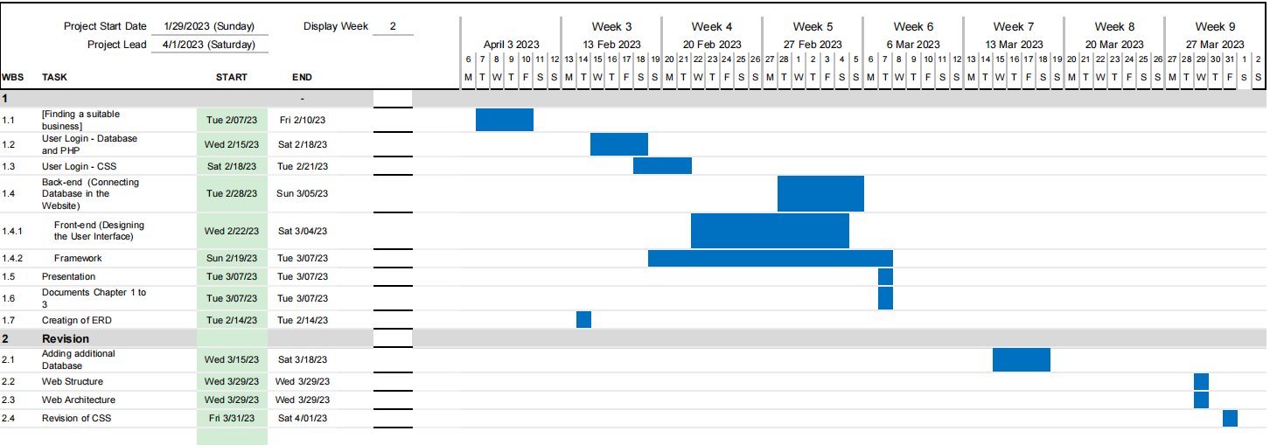

1. **Analysis**

One of the necessary objectives of the business is to track the transactions in order to record the sales of the business. Since the shop needs records of the transactions, Group 1 decided to create one for them. The group created a website application that contains job orders, finished transactions, and a list of technicians. The job order section consists of the job order list. This section is where the history of transactions is recorded, which contains the client’s name, contact information, total cost, service, and the date added. The Job Order section also contains the services offered by the business. The second one on the list is the Finished Transactions" section; it is where the finished transactions are added; it consists of Date Finished, Transaction ID, Technician’s Name, and Payment. Lastly, the settings section is where the technician’s information is placed.

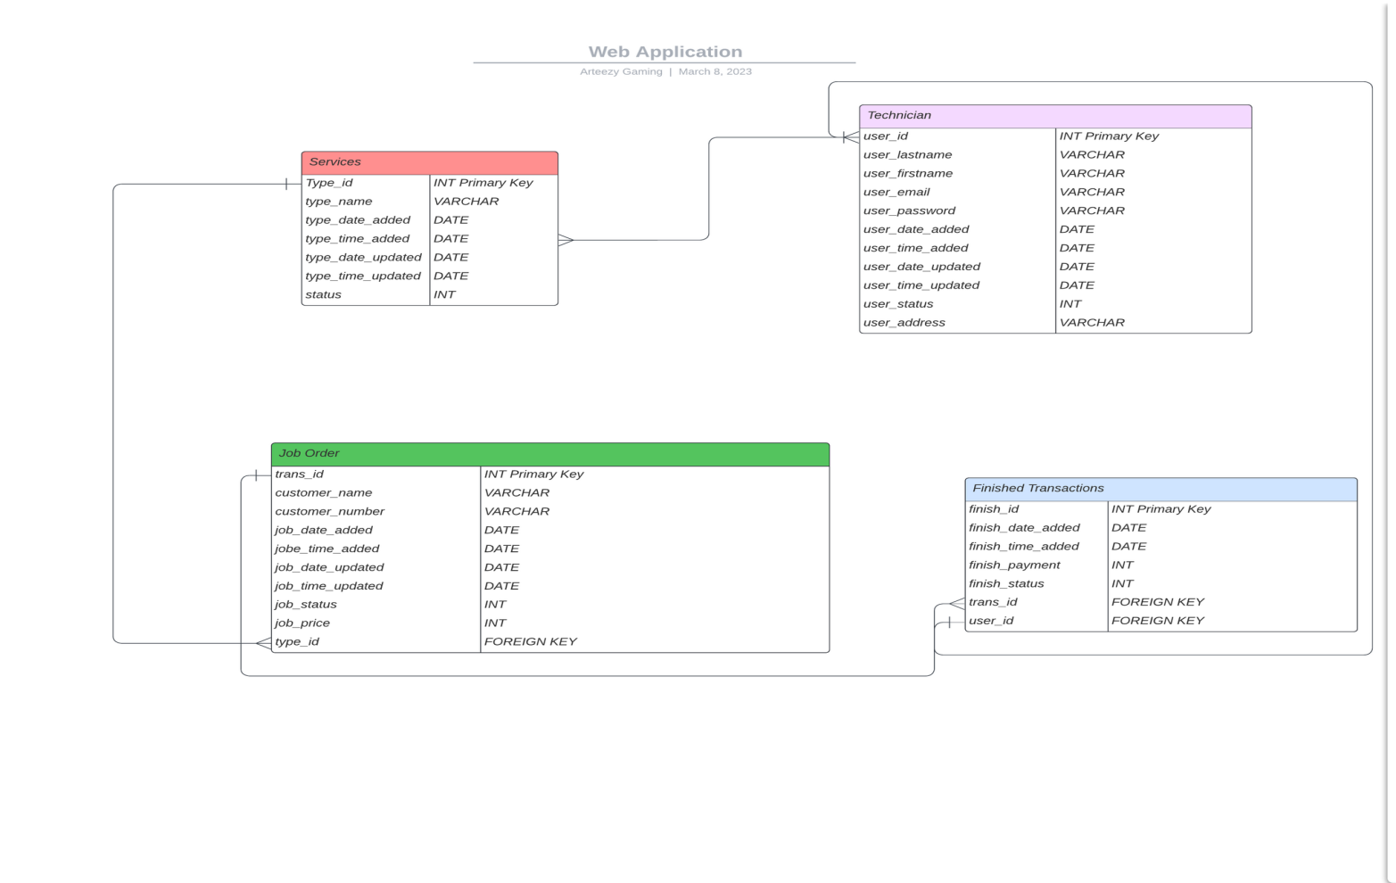The entity relationship diagram (ERD) represents represents the relationship of the table below:

1. **Design and development**

*Discuss what type of Web Application layout is appropriate, what forms of multimedia is helpful to the user.*

1. **Testing**

*Present and discuss functionality testing results.*

*vb*

1. **Implementation and Maintenance**

*Discuss how is the Web Application published, how is the Web Application is updated, who is responsible for content updates and will the Web Application be monitored.*

1. **Conclusion and Recommendation**

*What are your thoughts and takeaways on the case assigned to you? Do you agree on how the solution were implemented given their problems/challenges? You may also share your experiences and knowledge on the case to provide recommendations on how the organization can improve systems to achieve their vision.*

1. **References**

Use APA format. Make sure that your references came from academic journals, conference proceedings, books, and reputable websites.